CELEBRATE INTERNATIONAL CO-OPS DAY!
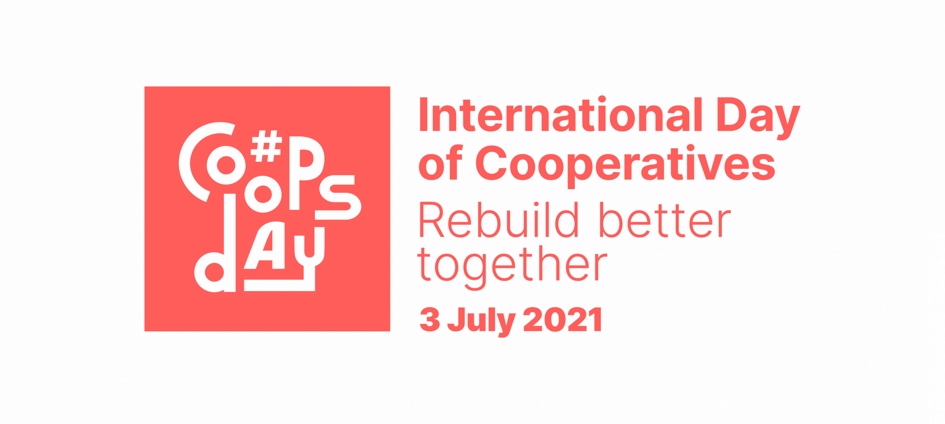
Rebuild Better Together!
International Co-ops Day is a great opportunity for your food co-op to join with other co-operatives and credit unions around the word in spreading the word about the Co-operative Difference. This year’s theme, Rebuild Better Together, highlights the resilience of co-ops during the pandemic and the role they are playing in helping our communities rebuilding in a more inclusive and sustainable way.
Here in our region, our food co-ops have played a key role in keeping our communities healthy and safe while ensuring access to healthy food and supporting local producers. In this packet you will find a few resources to help you communicate our shared impact:
- Use our template PRESS RELEASE (see next page) to share what you're doing with local media outlets and in your own newsletter, website or blog.
- Promote Co-ops Day using SOCIAL MEDIA (see page 3) and the hashtags #CoopsDay and #RebuildBetterTogether, and the Co-ops Day Logo (page 4).
- SHARE YOUR STORY with the International Co-operative Alliance! Submit your photos and activities and be included in the interactive Co-ops Day map!
For more background on International Co-ops Day, visit www.nfca.coop/co-opsday.
Please send a copy of anything you print or a link to online publications to erbin@nfca.coop. Thanks!

In Co-operation,
Erbin, Bonnie, Suzette & Alexis
Sample Press Release / Newsletter Story for NFCA Member Food Co-ops
International Co-ops Day is a great opportunity for your food co-op to join with other co-operatives and credit unions in spreading the word about the Co-operative Difference! We’ve drafted this story for you to adapt for use in your food co-op’s newsletter or e-news, blog, website, and as a press release to send to local media. You can also use excerpts for social media posts, using #CoopsDay. Please send a copy of anything you print or a link to online publication: erbin@nfca.coop. Thanks!

Contacts:
Your Press Contact Name  Your Co-op  Your Phone Number  Your E-mail | Erbin Crowell, Executive Director  Neighboring Food Co-op Association  Tel: 401-419-0381  E-mail: erbin@nfca.coop
FOR IMMEDIATE RELEASE – [DATE]:
[Your Co-op] Joins Celebration of International Co-ops Day

[Your City or Town] – On Saturday, July 3rd, [Your Co-op] is joining co-operatives and credit unions around the world in celebrating International Co-ops Day. This year’s theme, Rebuild Better Together, highlights the resilience of co-ops during the pandemic and the role they are playing in helping our communities rebuilding in a more inclusive and sustainable way.
[Use this space to give specifics about some of the ways that your Food Co-op served its community during the pandemic, and any initiatives, projects or programs that are ongoing. You could also include a quote on these efforts by a General Manager, Staff or Board Member, or a representative of a community organization that your co-op works with on these issues.]
“In the last year, we have witnessed how the co-operative model has been working towards the well-being of people and respect for the planet, underscoring what the co-operative movement stands for,” says Bruno Roelants, Director General of the International Co-operative Alliance (ICA). “We will indeed rebuild better together, and I’m confident that we will see many stories of how the co-operative movement can help communities become stronger in the post-pandemic world.”
International Co-ops Day has been celebrated annually since 1923, and the theme this year was chosen by the ICA and the United Nations to raise awareness of how co-ops have helped their communities weather the pandemic and are contributing to efforts to rebuild the economy.
“Across our region, food co-ops have worked to keep their communities safe while ensuring access to healthy, local food,” said Erbin Crowell, Executive Director of the Neighboring Food Co-op Association (NFCA). “And as we work to build back better, we know that our co-ops will be taking the lead in working together to ensure a more healthy, just, and sustainable future for everyone.”
The NFCA is a regional federation of more than 40 food co-ops and startups, locally owned by more than 163,000 members and employing over 2,340 people. During the pandemic, co-ops have been leaders in working to ensure that shoppers could access healthy food while remaining safe, including online ordering, curbside pick-up, and special shopping hours for at-risk consumers. At the same time, they remained committed to local producers, selling more than $100 million in local products annually – or over 25% of store sales, on average. Last year, more than 12,000 people joined their Neighboring Food Co-ops, reflecting growing interest in food security, community ownership, and economic inclusion.
As part of Co-ops Day celebrations, food co-ops across the Northeast are demonstrating their commitment to their communities and to building more inclusive economies as we work to rebuild in the wake of the COVID-19 pandemic. Celebrated internationally on the first Saturday in July, Co-ops Day in the United States coincides with Independence Day, offering a unique opportunity to focus on the democratic values of the co-operative business model. Based on the principle of one member one vote, co-ops reflect American ideals of democracy, self-help, self-responsibility, and social responsibility. And because co-operatives are focused on meeting member needs rather than maximizing profit, they are focused on goals identified by their members, including social, economic, and environmental sustainability.
[Depending on the timing of your release, you may also want to mention any special events or offers you have planned for July 4th weekend.]
For more information, please visit https://nfca.coop/co-opsday/.
## END ##
[±530 words with added content.]
For additional Co-ops Day social media ideas and graphics, see next page.
Sample #CoopsDay Social Media Posts
Copy and edit these template posts for your co-op’s use. See next page for Co-ops Day logos and images.
FACEBOOK
Posts for the two weeks leading up to July 3:
#CoopsDay is coming up on July 3, 2021! The @UN International Day of Cooperatives celebrates #RebuildBetterTogether and how co-ops are rebuilding in sustainable and inclusive ways! https://nfca.coop/co-opsday/
On July 3, celebrate #CoopsDay with your local food #coop! Your @Neighboring Food Co-op Association member co-ops sell more than $100 million in local products annually, supporting a more sustainable food system! https://nfca.coop/co-opsday/
#CoopsDay is coming up on July 3, celebrating the #coop contribution to Healthy Food, Healthy People, and a Healthy Planet! www.nfca.coop/co-opsday/
@UN #CoopsDay is coming up on July 3. Did you know that together our Vermont Neighboring Food #Coops are among the top 25 employers in the state? https://nfca.coop/about
July 3 is International #CoopsDay, celebrating the contribution of #coop businesses to #ClimateAction & #ClimateJustice. https://nfca.coop/co-opsday/
Co-ops are celebrating #CoopsDay as we #RebuildBetterTogether on July 3! Food co-ops in the Northeast have lower staff turnover and more staff employed fulltime than supermarkets in our region. For more info, check out: https://nfca.coop/co-opsday/
We’re celebrating #CoopsDay on July 3 with #coop members around the world and right here in our neighborhood! Take a look at this map of your Neighboring Food Co-ops: http://nfca.coop/members/
Take this opportunity to also post photos of staff, produce departments, and environmental initiatives, using #CoopsDay.
Post for July 3:
Happy International #CoopsDay! Come down to your food #coop and celebrate sustainability with the best staff on the planet. [Post with a photo of staff.]
Happy International #CoopsDay! Together, we’re #RebuildingBetterTogether and growing a more just and sustainable future for everyone! [Post with a photo of staff, a co-op event, or expansion at your co-op.]
TWITTER
Sample posts for the two weeks leading up to July 3:
On July 3, celebrate #CoopsDay with your local food #coop! Here in the Northeast, our @Neighboring Food Co-op Association member co-ops sell more than $100 million in local products, supporting a more sustainable food system! https://nfca.coop/co-opsday/
#CoopsDay is coming up on July 3, celebrating the #coop contribution to #ClimateAction & #ClimateJustice! https://nfca.coop/co-opsday/
The 25th Annual @UN #CoopsDay is coming up on July 3. Did you know that together our Vermont Neighboring Food #Coops are one among the top 25 employers in the state? www.nfca.coop/about
July 3 is International #CoopsDay, celebrating the contribution of #coop businesses to sustainability. https://nfca.coop/co-opsday/
Co-ops are celebrating #CoopsDay as we #RebuildBetterTogether on July 3! Food co-ops in the Northeast are committed to sustainable sourcing practices. For more info, check out https://nfca.coop/co-opsday/
We’re celebrating #CoopsDay on July 3 with #coop members around the world and right here in our neighborhood! Take a look at this map of your Neighboring Food Co-ops: http://nfca.coop/members/
Take this opportunity to also post photos of staff, produce departments, and environmental initiatives, using #CoopsDay.
Sample posts for July 3:
Happy International #CoopsDay! Come down to your food #coop and celebrate sustainability with the best staff on the planet. [Post with a photo of staff.]
Happy International #CoopsDay! Together, we #RebuildBetterTogether creating a more just and sustainable future for everyone! [Post with a photo of staff, a co-op event, or expansion at your co-op.]
#CoopsDay Images
Logo
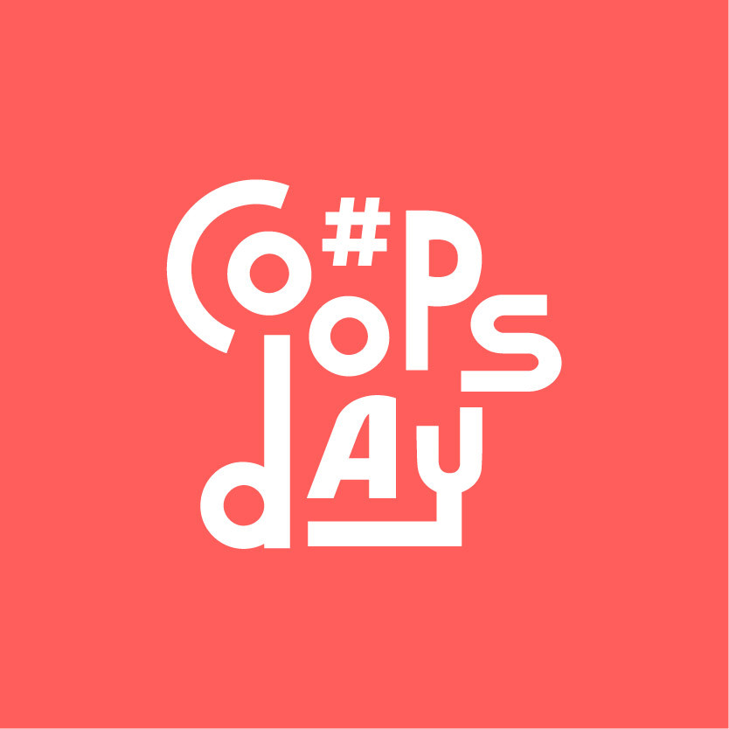
Facebook Banner

Poster
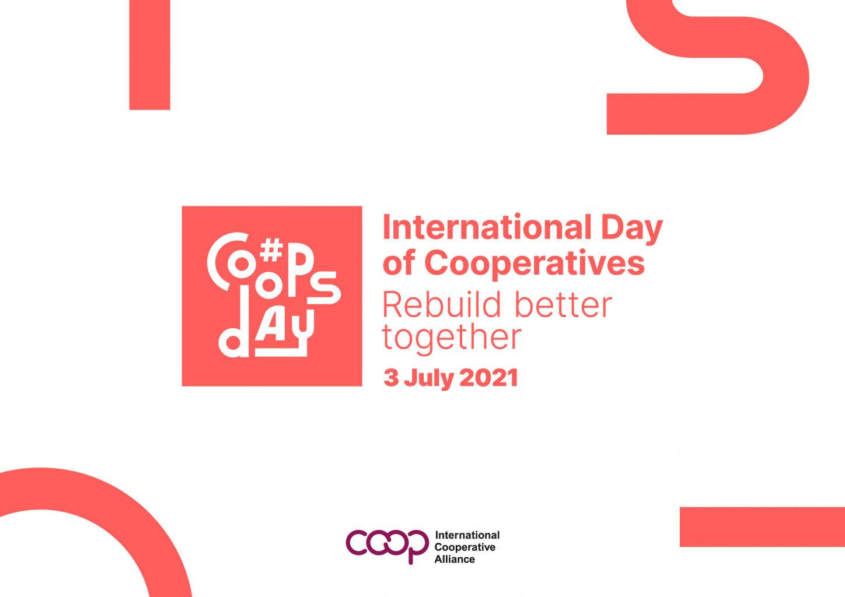

For additional images, visit https://www.coopsday.coop/.

