Food Co-ops and Healthy Food Access Project
Tool Box: Food For All Program, version 4 (August 2013)
Table of Contents
About the Food Co-ops and Healthy Food Access Project 2
Program Handbook 2
Introduction to Food For All 2
Case Study 4
Framework 6
Essential Elements of Food For All 6
Program Clarity 7
Membership Cards 7
Point of Sale System 7
Partnerships 8
Staff Capacity 8
Welcoming Environment 9
Legal Considerations 10
Budget Implications 10
Co-op Ends Statement 11
Potential Innovations and Supporting Programs 11
Eligibility Verification 11
Equity Share Purchase 11
Education around Purchases 12
Statewide Collaboration 12
Attached Materials 12
Healthy Food For All Brochure, Wild Oats Market, Williamstown, MA 13
Food For All Program Fact Sheet, City Market, Burlington, VT 15
Membership Form, City Market, Burlington, VT 16
Rack Card, City Market, Burlington, VT 17
Pennywise Pantry, City Market, Burlington, VT 18
Enrollment Instructions, City Market, Burlington, VT 19
FLOWER Application, GreenStar Co-op, Ithaca, NY 23
FLOWER Flier, GreenStar Co-op, Ithaca, NY 25
FLOWER Brochure, GreenStar Co-op, Ithaca, NY 26

About the Food Co-ops and Healthy Food Access Project
The Cooperative Fund of New England (www.coopfund.coop) and the Neighboring Food Co-op Association (www.nfca.coop) are partnering to help food co-ops make wholesome, nutritious food more accessible. The "Food Co-ops and Healthy Food Access" project (FCHFA) strives to increase access to healthy food for those with limited means; support collaboration among food co-ops to engage and serve individuals and families with limited food budgets; and demonstrate the capacity of food co-ops to increase access to healthy food and business ownership for everyone. With a programmatic focus in western New England, project partners will share materials nationally through presentations and print and electronic media.
FCHFA surveyed 29 food co-ops, largely in Western New England, to identify successful and improvable programs striving to utilize the food co-op enterprise to expand access to healthy food for underserved communities. From this survey, FCHFA developed a framework of six components to a healthy food access strategy that co-ops should consider when designing their programs: Collaboration with Partner Organizations, Educational Opportunity, Product Affordability, Accessible Ownership Options, Inclusive Marketing and Infrastructure. Interested readers can find more information about this framework at www.nfca.coop/framework.
FCHFA is interested in hearing feedback on this framework, and programs in place to achieve healthy food access. Please contact healthyfoodaccess@coopfund.coop.
This project would not be possible without the support of The Cooperative Foundation, Howard Bowers Fund, CoopMetrics, the National Cooperative Grocers Association, and Newman’s Own Foundation. To learn more about FCHFA, visit: www.nfca.coop/healthyfoodaccess.

Program Handbook
This Program Handbook aims to provide comprehensive detail on the Food For All program which will help co-ops and their communities evaluate the relevance of this program to their situation, and, if appropriate, easily implement it. If you think Food For All can help your co-op and community but can’t find information that you need to implement it, please contact healthyfoodaccess@coopfund.coop.

Introduction to Food For All
The City Market/ Onion River Food Co-op, in Burlington, VT, found itself in an interesting situation when the Recession of 2007 hit. As the main grocery store in downtown Burlington, Vermont’s largest city, the Co-op felt a particular responsibility to respond to the growing population who struggled to put healthy food on their table. As the Co-op is owned by almost 8,000 (as of June 2012) of Burlington’s community members, they were able to develop an innovative program to respond to the growing need.
They developed the Food For All program to assist people receiving various public benefits, including SNAP (formerly Food Stamps--the Vermont version is called 3SquaresVT), WIC, and disability benefits, by offering them a 10% discount on all non-alcohol grocery purchases. Since the program began in May 2008, it has been a major success. Between 2005 and 2008, before the Food For All program started, EBT (Electronic Balance Transfer) use for 3SquaresVT and WIC sales increased between 6 and 12% annually. In the first two years of the program, EBT sales increased by 47% each year. By 2011, EBT use for 3SquaresVT and WIC sales was 80% higher than in 2009. In the program’s first 12 months, 578 new members took advantage of its benefits. As of 2012, the Co-op has more than 1,140 individuals and families enrolled. In that same fiscal year, the co-op recognized that 5% of their total sales (or $1.6 million) came from participants in the Food For All program. This figure both represents a growing portion of Food For All purchases compared to the co-ops sales, and a growing absolute volume of Food For All sales, since overall co-op sales have grown. While some of that growth may have occurred due to the recession regardless of the Food For All program, these numbers show the growing role that the co-op played in serving low-income community members.
This success comes, in large part, from the collaboration with local nonprofits that promote Food For All to their clients. Marissa Parisi, Executive Director of Food For All partner Hunger Free Vermont, sees the program as “allowing people to make their money go further while providing other benefits that are unique to co-ops; such as food related education and bulk items that are culturally appropriate for diverse populations.” Food For All has been a successful way for City Market/ Onion River Co-op to reach a demographic that has historically not taken advantage of food co-ops. When asked what he would do differently if he was given the chance, the co-op’s former General Manager Clem Nilan, who implemented the program, responded: “Start earlier.”
The goal of developing this tool box is to encourage food co-ops and community organizations to partner, consider the relevance of this program to their community’s needs, and access information to facilitate the adaption and implementation of this type of program locally.
While this toolbox largely focuses on City Market, it references similar programs at other co-ops. In New England, Hunger Mountain Co-op (Montpelier, VT) and Wild Oats Co-op (Williamstown, MA) have established programs as of 2012, and many more are designing or implementing programs as this guide is finalized. GreenStar Co-op (Ithaca, NY) also has an established program that is referenced here. GreenStar’s program has some notable results, with 395 people currently enrolled in their FLOWER program (Fresh, Local, Organic Within Everyone’s Reach). They are more aggressive than City Market with their discount, offering 15%. Alexis Alexander, Membership Manager shares: “When I talk with FLOWER participants, they share stories of how the FLOWER discount gives them the ability to shop at GreenStar and get access to everything they need—whether it is basic healthy food or specific foods for customers with food allergies... Many community members have jobs, but they still don’t make enough money to afford rent and purchase healthy food, so the FLOWER program helps more community members to do this.”

Case Study
FOOD CO-OPS & HEALTHY FOOD ACCESS PROJECT
Cooperative Fund of New England & Neighboring Food Co-op Association
“Food For All,” a Program of City Market/Onion River Co-op
City Market / Onion River Co-op
Burlington, VT
Established: 1973 (as a buying club) Members: 7,500
Annual Sales: $30 Million
Retail Space: 16,000 sq. ft. of retail
Product Mix: 75% Natural & Organic Products, 25% Conventional
City Market/Onion River Co-op located in Burlington, VT has been serving its members and the larger community since it began in 1973 as a buying club. In 2002, the Co-op moved to its current location in downtown Burlington to occupy 16,000 sq. ft. of retail space leased to them by the city. Carrying around 75% natural and organic foods and 25% conventional, this store provides everything its customers, including its almost 8,000 member-owners (as of June 2012), could hope to find in a supermarket. To better serve those with limited means, who struggle with the higher cost of natural, organic, and fair trade items, City Market/Onion River Co-op developed its Food For All program.
The Program
Food For All assists those who are currently receiving 3SquaresVT, WIC, or disability benefits by offering them a 10% discount on their grocery purchases, except alcohol. In order to receive this discount, applicants must join City Market/Onion River Co-op. They can apply for a one-year renewable waiver on buying their share, but until they begin making equity payments, they can’t receive patronage dividends or have voting rights. Requiring participants in the Food For All program to become members provides a discrete way for participants to receive the discount at check-out, as they simply swipe their membership card — like any other member — and the discount is automatically applied. Membership also allows the Co-op to easily track various data on the success of the program.
Since the program began in late 2008 it has been a major success. This is, in large part, because of the support of local nonprofits promoting the program to those with limited incomes. The relationships with almost a dozen of these local nonprofits has been the most successful technique for marketing the Food For All program and has vastly increased the number of participants. In the program’s first 12 months, the Co-op had 578 new members taking advantage of the program. As of 2012, the Co-op has 1,148 individuals and families enrolled in Food For All. In 2011, the Co-op recognized sales of $1.6 million through the Food For All program; this is over 5% of total sales for the Co-op. Marissa Parisi, Executive Director of Food For All partner Hunger Free Vermont, sees the program as, “allowing people to make their money go further, while providing other benefits that are unique to co-ops — such as food related education and bulk items that are culturally appropriate for diverse populations.” In addition to drawing in more US-born low-income shoppers, City Market/Onion River Co-op has also seen its program bring in a growing number of people from Burlington’s large refugee resettlement population who are attracted to the Co-op’s bulk items.

The Cost to the Co-op

Most of the cost of implementing this program was up front. Marketing the program, creating systems to monitor and support it, and figuring out the financial implications required some staff time. Once in place, the biggest burden of the program falls on Member Services staff — who are responsible for enrolling and communicating with participants — but the additional work of enrolling members in this program rather than the traditional member/owner category is minimal. As for the financial cost of the program, former General Manager Clem Nilan, who implemented the program, stresses that it “does not cost us anything, it enhances our revenue and profitability,” because it brings in shoppers who would not come otherwise. Sales to members in the Food For All program cover the cost of the goods and overhead, so the Co-op does not lose money by offering this program; it just makes less on the margin than it does in sales to other members and shoppers.
Challenges
One of the biggest challenges involved in the Food For All program has been transitioning members of this program into becoming equity owners of the Co-op. Approximately 250 Food For All members are equity owning members, the other 900 are not receiving patronage dividends or voting in Co-op elections or ballots. Many of these members are also buying mostly conventional items, although over time, some Food For All members have shifted toward choosing more natural and organic products.
There were some potential legal issues that City Market/Onion River Co-op had to face when implementing this program. Anti-discrimination laws that protect those receiving benefits from being treated differently from other consumers can be applied even when you are offering additional assistance. The Co-op extended this discount to people receiving a variety of services and required that they were members so that the discount was not singling out any one group of individuals for receiving a specific benefit. Co-ops looking to institute a similar program should consult with legal counsel about federal, state, and local laws around this issue.
Suggestion for Replication
City Market/Onion River Co-op has done an excellent job in tracking the success of this program: they look at the number of members involved, the sales trends of these members, and the percentage of membership and sales that these members encompass. Tracking this information can help co-ops clearly see the program’s impact — both for the Co-op, and the broader community. If food equity is a priority for your co-op, it is also a valuable tool for showing how a co-op is achieving its mission or “Ends”.
The Food For All program has been a successful way for City Market/Onion River Co-op to reach a demographic that has historically not taken advantage of food co-ops. When asked what he would do differently if he was given the chance, General Manager Clem Nilan responded: “Start earlier.”
Profile by Dana Clawson
This profile was developed as part of “Food Co-ops & Healthy Food Access,” a joint project of the Cooperative Fund of New England (CFNE) and the Neighboring Food Co-op Association (NFCA). The goals of the project are to increase access to healthy, regionally-sourced food and food co-op member/ownership and participation; to support information sharing among food co-ops on programs related to low-income access; and to raise the profile of food co-ops as a solution to the challenge of healthy food access in our region. For more information, please visit www.nfca.coop/healthyfoodaccess.

Framework
As previously discussed, the Food Co-op and Healthy Food Access project identified six components to healthy food access that food co-ops should consider when trying to increase access for underserved communities. Food For All incorporates four of these: 1) Collaboration with Partner Organizations, 2) Product Affordability, 3) Accessible Ownership Options and 4) Inclusive Marketing.
- Collaboration with Partner Organizations: Food co-ops, including City Market, do not generally have the resources to adequately reach underserved consumers on an individual level. Food For All relies on partnerships with community organizations to market the program and inform potential beneficiaries of the Co-op’s services.
- Product Affordability: For a number of reasons, food co-ops struggle with perceptions and some realities regarding product affordability. For many food co-ops, there is the central tension between being affordable to people of all economic means while also facilitating economic support of food systems that provide high nutrition, protect human and ecological health, and promote fair relationships with small producers and farm workers. The 10% discount for Food For All participants directly helps off-set these higher costs.
- Accessible Ownership Options: Co-op member-owners gain two important rights, patronage dividends (profit sharing) and voting. But these rights come at a cost, as member-owners contribute funds towards the Co-op’s equity for a full member share. City Market members, for instance, normally contribute $200 of equity to the co-op. While participants have the option of accessing a Non-Shareholding Membership (see Membership Cards below for details), the Co-op offers a Member Share payment plan of $15 per year, up to the full $200 membership share. High volume shoppers would find benefit from joining on the financial side alone, as a patronage dividend would cover the $200 membership share in a matter of a couple years. Additionally, an organized voice of Food For All participants could have the political power within the co-op to elect Board Members and advocate for more services to support their participation. See the Potential Innovations section below for more thoughts on this topic.
- Inclusive Marketing: What is your Co-op doing to make EVERYONE feel welcome? If you want more customers with limited budgets to come to your co-op, it is important to market to low-income shoppers. Co-ops can create a welcoming environment by designing signage, marketing, providing products that appeal to low-income consumers. For example, co-ops stores can display small signs that say “Great Deal!” or “Everyday Basics!” or something similar next to affordable healthy items such as like in-season produce, milk, bulk grains, and dry beans. In response to their customers’ requests, City Market added more conventional products to their store in order to be able to meet all of their customers’ shopping needs and welcome more community members into their store.

Essential Elements of Food For All
FCHFA identified nine essential elements of the Food For All program for you to consider when evaluating this program’s appropriateness to your co-op: Program Clarity, Membership Cards, Point of Sale Systems, Community Partnerships, Staff Capacity, Welcoming Environment, Legal Considerations, Budget Implications, and the Co-op Ends Statement.

Program Clarity
For Food For All to be successful in your community, you should have clarity on the purpose and design of the program.
Food For All addressed three core barriers to food co-ops providing healthy food access to underserved communities: 1) increased access to information about the co-op, through community partners, 2) product discounts specifically for people on a limited food budget, and 3) accessible co-op membership.
You should consider: 1) how much of a discount you will offer, 2) to whom, 3) on what items. City Market decided to offer a 10% to all members enrolled in certain public benefits to purchase groceries except for alcohol (based on current Vermont laws). They made their membership process more flexible by adding in a Non-Shareholding Membership, which requires no equity contribution. This might not be right for your community, but it is one option to consider.
Your Board and Management will need to be comfortable with the reduced margins and start-up costs to the program. Ideally, the increased sales resulting from the program will off-set the reduced margin on those products, as it has for City Market.
City Market did not specifically track the staff and volunteer time going into the Food For All start-up effort, which comprised, for them, virtually all of the start-up costs. The volunteer committee identified and designed the outline of the program, and the staff designed and implemented the detailed level.
Some questions for consideration:
- How will you cover the start-up costs?
- Who will be responsible for what aspects of the program, including designing the program, enrolling participants, and monitoring its impact?

Membership Cards
Use of Point of Sale readable Co-op Membership Cards was essential to City Market’s ability to quantify Food For All’s impact, while maintaining the confidentiality of program participants. Food For All participants must join the Co-op, but are eligible for a free, one-year, renewable Non-Shareholding Membership. This membership has no voting rights or patronage dividends, but also avoids the $200 membership equity contribution or the $15 per year payment plan (up to the $200 amount).
Participants are issued a membership card that they use at the register to access their 10% discount. These membership cards, as well as their equity forms, look identical to the Shareholding Membership cards, but with a different barcode. By relying on a membership card to access the discount, the Co-op can track program participation and impact. Additionally, as Non-Shareholding Membership cards look identical to a standard membership card, participants can access benefits discretely.

Point of Sale System
In addition to the Membership Cards, City Market uses a Point of Sale system that can handle applying the discounts to the appropriate sales. To fully implement the program a POS system should be able to track the following:
- Individuals with subsidies, including both those with equity shares and those on a waiver;
- Overall sales using the Food For All program; and
- How much of which items are being sold through Food For All. This will help the Co-op know if, over time, participants are shifting purchasing from conventional products to those that better meet the Co-op’s Ends Statements (local, organic, etc.) or from low-nutrient foods, like sodas, to high-nutrient foods, like low-fat milk.
Additionally, the program should ensure that discounts only apply to the applicable items. For example, City Market excludes alcohol from the program, so they needed to set up their POS system to apply the discount to all non-alcohol items.

City Market uses Store Management Suite (SMS) version 3.2.0 by LOC Software, for their Point of Sale Software and is willing to share their POS solutions to interested co-ops.

Partnerships
As previously mentioned, this program relies on partnerships with low-income community groups and social service providers to reach potential program participants. The Co-op approached Hunger Free Vermont (HFVT) as a key partner in the program. HFVT incorporated in 1993 with the mission to end the injustice of hunger and malnutrition for all Vermonters. They provide outreach and education programs around the state’s various anti-hunger programs, including 3SquaresVT (Vermont’s SNAP program, formerly called the Food Stamp program), school meal programs, and nutrition.
City Market has a long-standing partnership with HFVT. The Co-op funds some of HFVT’s programs, and HFVT consults with the co-op to address hunger and malnutrition. For instance, HFVT suggested that the co-op post signage reminding customers that 3SquaresVT will cover vegetable seeds purchases. The City Market – HFVT partnership has evolved to the point that in fall 2012, Co-op members elected a staff member from HFVT to serve on their Board.
Because of HFVT’s history and scope, they were able to recruit other partners into Food For All. These program partners promote Food For All through their existing programs, reaching a wide range of eligible populations. City Market staff also write articles for Vermont’s WIC newsletters and, with the assistance of their partners, target some of their storewide tours to specific populations.
GreenStar Co-op (Ithaca, NY) has connected with the local WIC program in their community, giving them program applications and flyers, so now the local WIC staff speak to all of their clients about what the Co-op offers. GreenStar plans to reach out to other public agencies to expand their impact.

Staff Capacity
While this program isn’t labor intensive, it does require some staff time--and particularly staff training-- on an on-going basis. While this program might originate with the member services staff, the front end staff will be operating it so you might consider involving them in the program design. Staff should be educated about how their Food For All program works to help customers use their membership card, and to remind them when they need to renew while respecting their privacy. They should also understand the basics of programs like SNAP and WIC that customers may be using to make their purchases. Implementing an on-going feedback loop from front end staff to the training staff will help evolve the training and programs to address outlier situations. City Market is working with Hunger Free Vermont on front end staff training. To support City Market in creating a welcoming environment, HFVT staff have made several presentations to City Market staff about the 3SquaresVT and WIC programs, sharing information that will help staff provide more empathetic, customer-oriented service to all customers, including those who participate in Food For All.
Staff members also need to communicate with participants about their eligibility for the program and an equity waiver. Upon the anniversary of a participant’s enrollment in the program, staff need to assess whether to renew their participation and waiver, transfer the participant to an equity shareholding membership, or cut them from the program. City Market is currently exploring options for supporting participants to invest in an equity share, including learning why they are not investing. Figuring this out would both give the co-op more equity capital and give these members full access to all the benefits of cooperative membership.
GreenStar Co-op’s program utilizes 10 hours a week of member services staff time for their outreach efforts, though other co-ops haven’t allocated this much.

Welcoming Environment
Food For All will be most successful if low-income community members feel welcomed and comfortable shopping in your co-op. Staff training, mentioned above, is an important tool in creating a welcoming environment. If your staff are knowledgeable about food assistance programs and Food For All, they will be able to answer questions participants may have, problem solve, provide excellent customer service, and help all shoppers to feel more welcome. An educated staff who provide friendly customer service to all customers, regardless of membership, helps combat stigma against food assistance programs and low-income community members and helps all customers feel more welcome in the co-op environment.
Stores can also create a welcoming environment through signage, displays, and messaging throughout the store. Advertisements and signs in the entryway that tell customers which forms of payment are accepted, such as SNAP or WIC, clearly welcome all customers into the co-op. Additional signage throughout the store highlighting affordable, healthy, food items help customers know what products are within their budget and help improve customers’ perception about the value and prices at your co-op. Stores may consider lowering the price of basic pantry items and promoting them through signage.
Co-ops often have different product lines and store sections than conventional grocery stores, which can be intimidating for new customers. Providing educational opportunities, either through store tours, shopping on a budget classes, or informational pamphlets, will help customers navigate your store comfortably. They can also help introduce customers to new food items or cooking skills. Bulk and produce sections can be especially intimidating to customers, and clear signage and informational materials is very helpful. City Market, for example, has brochures in the bulk section about different products and clear signage explaining how to use the bulk section. They also provide regular store tours that highlight healthy, affordable products called the Pennywise Pantry and the Frugal Fridge.
Finally, creating a welcoming environment for all who enter your store can encourage more customers to become co-op members. Food For All participants are an ideal group to target with outreach around membership, as they are already engaging with the co-op and receiving a benefit. Creating accessible ownership options, as discussed earlier, helps all shoppers feel more able, and encouraged, to join the co-op as a shareholding member and to have a voice in the co-op’s governance. Co-ops can create educational materials promoting the benefits and value of becoming a member, from the financial benefit of a patronage refund and the opportunity to represent your needs through serving on the Board of Directors, to the intrinsic value of having ownership of the co-op. Staff can also be trained to encourage Food For All participants to consider becoming shareholding members, especially when participants are renewing their non-shareholding membership.
Finally, your customers may have varying levels of English comprehension. If your co-op is located in an area where other languages are often spoken, consider displaying information in multiple languages. Additionally, keeping all language in signs and marketing materials clear and easy to understand will help all customers feel welcome.

Legal Considerations
There were some potential legal issues that the City Market/ Onion River Co-op had to face when implementing this program. Anti-discrimination laws protect those receiving federal benefits from being treated differently from other consumers, even in beneficial ways. The Co-op worked with the USDA’s Food and Nutrition Service field office for approval of the program. The two key aspects of the program are 1) that individuals on a variety of subsidy programs (not just SNAP or WIC) are eligible for Food For All and 2) having the Food For All discount as a member benefit allows for privacy at the check-out. Co-ops looking to institute a similar program should consult with legal counsel about federal, state, and local laws around this issue.

Budget Implications
As with all new major programs, co-op management should consider the budget implications of the program. With Food For All there are three areas to be considered: implementation costs, impact on existing sales, and projected new sales. An implementation budget might consider staff time for communicating with members, training staff, designing and printing materials, and advertising costs (print, radio, etc.). Co-ops should expect to lose some income from the impact of the discount on existing sales to qualifying members. If your co-op already tracks some aspect of sales to low-income members, such as SNAP and WIC sales, estimating your lost income from the program could be as simple as multiplying your discount by the amount of those sales, though that might not give the whole picture if your current SNAP and WIC members make unsubsidized purchases beyond the value of their benefits.
Estimating the amount of new sales generated by the program is harder. New sales will come both from existing qualifying members purchasing more from the co-op and new members attracted to the co-op by the program. These estimates could be informed by demographic data, such as the number of low-income residents of the community, as well as the size of the community. By looking at three co-ops in the Northeast who have FFA type programs (Hunger Mountain, City Market and GreenStar), we found that the average sales per participating member for two of the co-ops ranged between $1,000 and $2,000 between 2011 and 2012, and increased year after year. The third co-op had decreasing average sales in the $3,000 to $4,500 range. By calculating the impact on existing sales and projecting new sales, a co-op considering this program could estimate how many new members the program needs to break even. As more co-ops implement Food For All type programs, we hope to better understand how co-ops can predict the financial impact of the program.
Co-ops account for needs based discounts slightly differently, with City Market allocating the discounts to their Member Services department and GreenStar allocating the discounts to their profit and loss statement after their total sales and before their gross profit. This is something worth considering. Your co-op might want to avoid charging the discount to individual departments as that might effectively penalize the departments who are most directly serving low-income members.

Co-op Ends Statement
City Market found that having an Ends Statement that includes healthy food access helped management and members agree to allocate resources to this program. An addendum to their Ends Statement includes the following: “Our goal is to provide low-income consumers with access to progressive, social, and healthful choices through education and outreach and to specifically reduce childhood hunger in Burlington.”

Potential Innovations and Supporting Programs
While FCHFA sees the Food For All program as a success worthy of replication, there are a couple areas that might benefit from improvement or innovation. These include: improving the system to verify applicants’ eligibility, implementing mechanisms to encourage equity share purchases, education for participants around purchasing products that further the co-op’s other goals (strengthening the local food system, in City Market’s instance), and exploring state-wide collaboration on the program.

Eligibility Verification
City Market is still fine-tuning their process for verifying that an individual is eligible for Food For All. This process is complicated by the necessity for Food For All eligibility to not be tied to a specific government benefit program (see Legal Considerations above). 3Squares VT distributes benefits to some recipients through direct deposit, not an EBT card, but the co-op does not want to look at individual bank statements to verify eligibility. Additionally, the co-op cannot rely on a Food For All applicant just showing an EBT card, as the co-op doesn’t know if it’s active. The co-op staff need as simple of a verification system as possible for the program to work. City Market is working with Hunger Free Vermont to improve this part of the program, but this area is still in progress.
Co-ops replicating Food For All also need to consider how participants will renew their eligibility annually. The Wild Oats Co-op, in Williamstown, MA, has all eligibility expire at the same time of the year (May 30th), so they can process all renewals at once.

Equity Share Purchase
Only about 200 of City Market’s 1,150 Food For All participants are equity share members, with the rest on the annually renewable waiver. By innovating to help Food For All participants purchase equity shares, the co-op would create a path to wealth creation, however limited, though the patronage dividend, and to political participation, through voting rights in the co-op. This would minimize the co-op’s internal barriers to full participation.
One possible avenue would be to explore applying the unearned patronage dividend that Non-Shareholding Members miss towards the purchase of the member share. Potentially the co-op could say that until the member share is fully purchased, the member’s dividend must go towards purchasing that share. City Market’s attorney saw this as an inequitable solution, but maybe there is another way forward on this.

Education around Purchases
More ethically traded products (fair trade, organic, unionized companies, etc.) often carry a higher price tag, putting the product out of reach for people shopping on a tight budget. Sometimes, though, these products are actually affordable (or even more affordable, in the case of bulk items) to shoppers, but they choose conventional products out of habit. Implementing educational programs designed for Food For All participants could help shift their habits to supporting a more sustainable economy.
As many food co-ops have a strong history of these education programs, the issue may just be how to structure them to make them accessible and relevant to Food For All participants.

Statewide Collaboration
In the event that multiple co-ops in the same state want to implement this program, there may be benefits from approaching the design collectively. This might be particularly useful when approaching potential community partners and navigating the legal and verification issues around various eligibility criteria. Furthermore, this type of collaboration might help co-ops who are on the fence about this program decide to implement it, further expanding access to healthy food through food cooperatives.

Attached Materials
Attached are a few produced materials related to the Food For All program, and its sister programs at Wild Oats Co-op called Healthy Food For All (HFFA) and GreenStar Co-op called FLOWER.

Healthy Food For All Brochure, Wild Oats Market, Williamstown, MA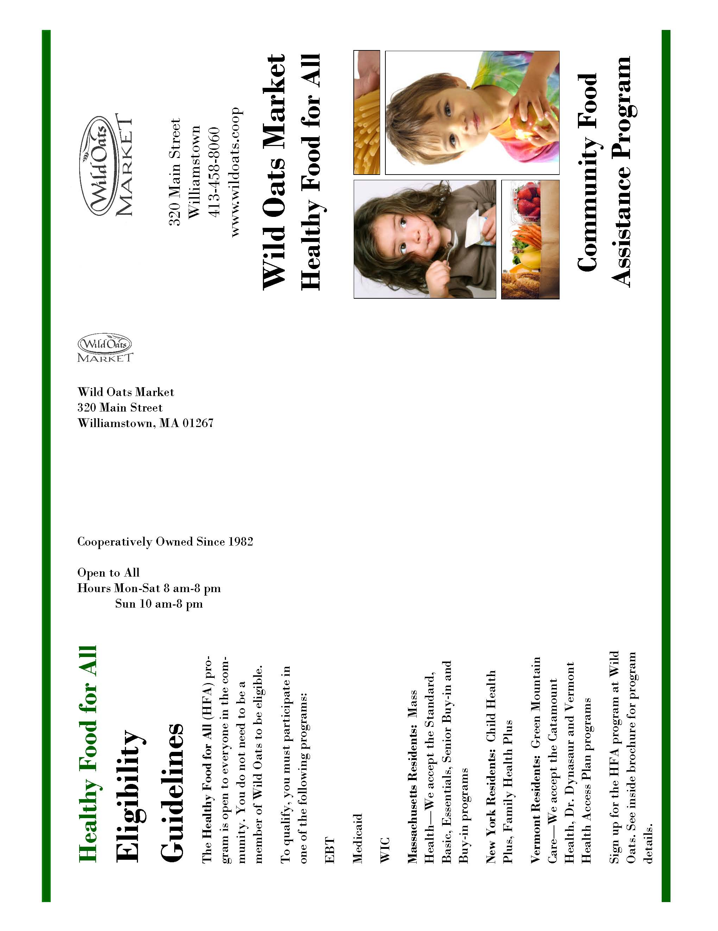

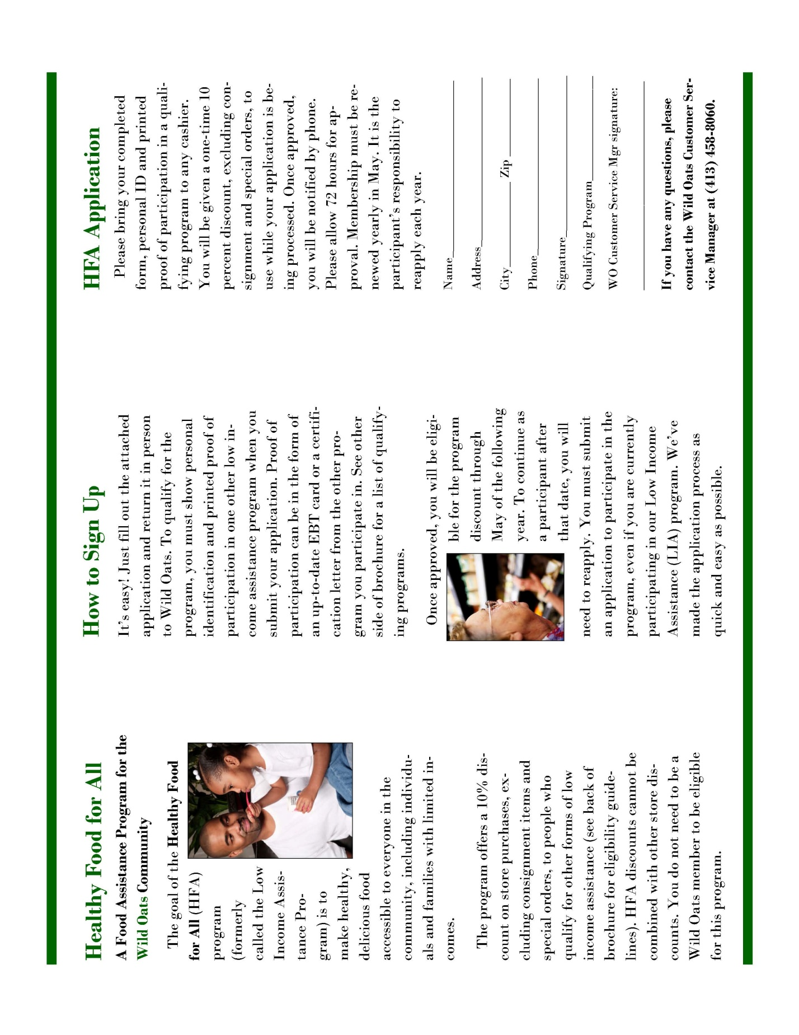

Food For All Program Fact Sheet, City Market, Burlington, VT
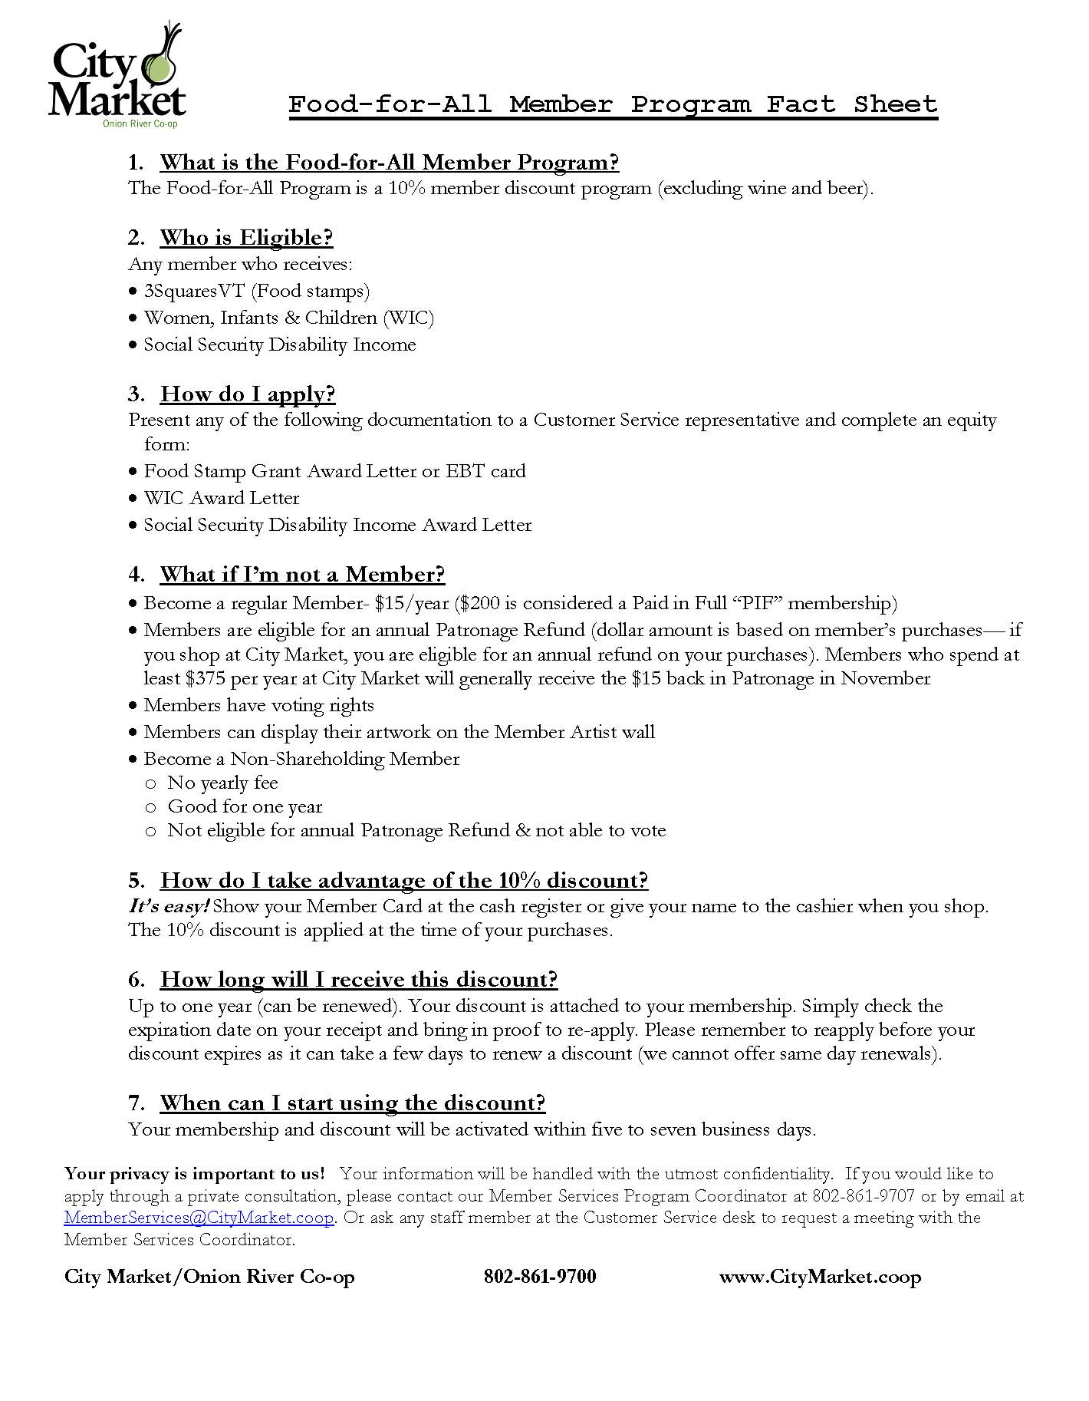

Membership Form, City Market, Burlington, VT

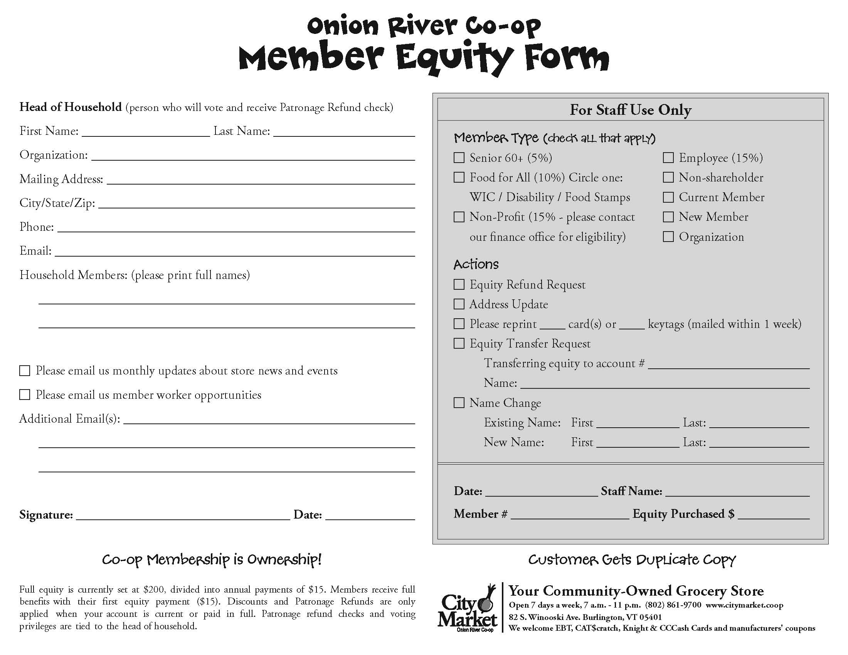

Rack Card, City Market, Burlington, VT

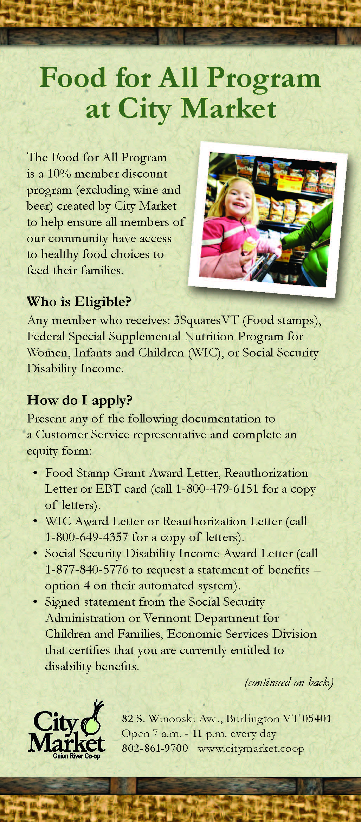
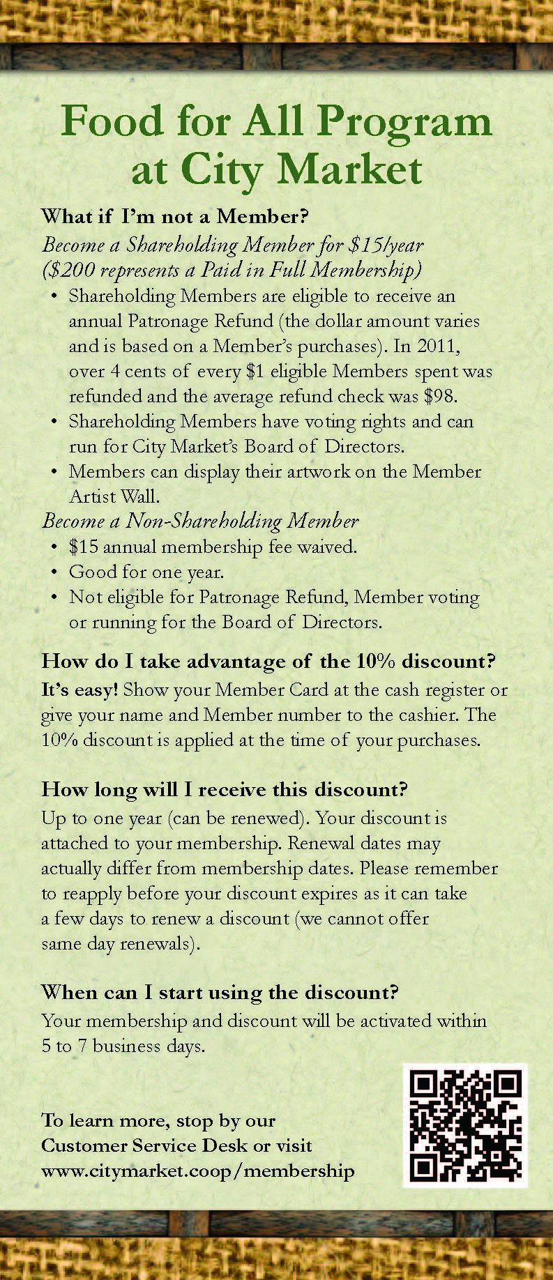

Pennywise Pantry, City Market, Burlington, VT

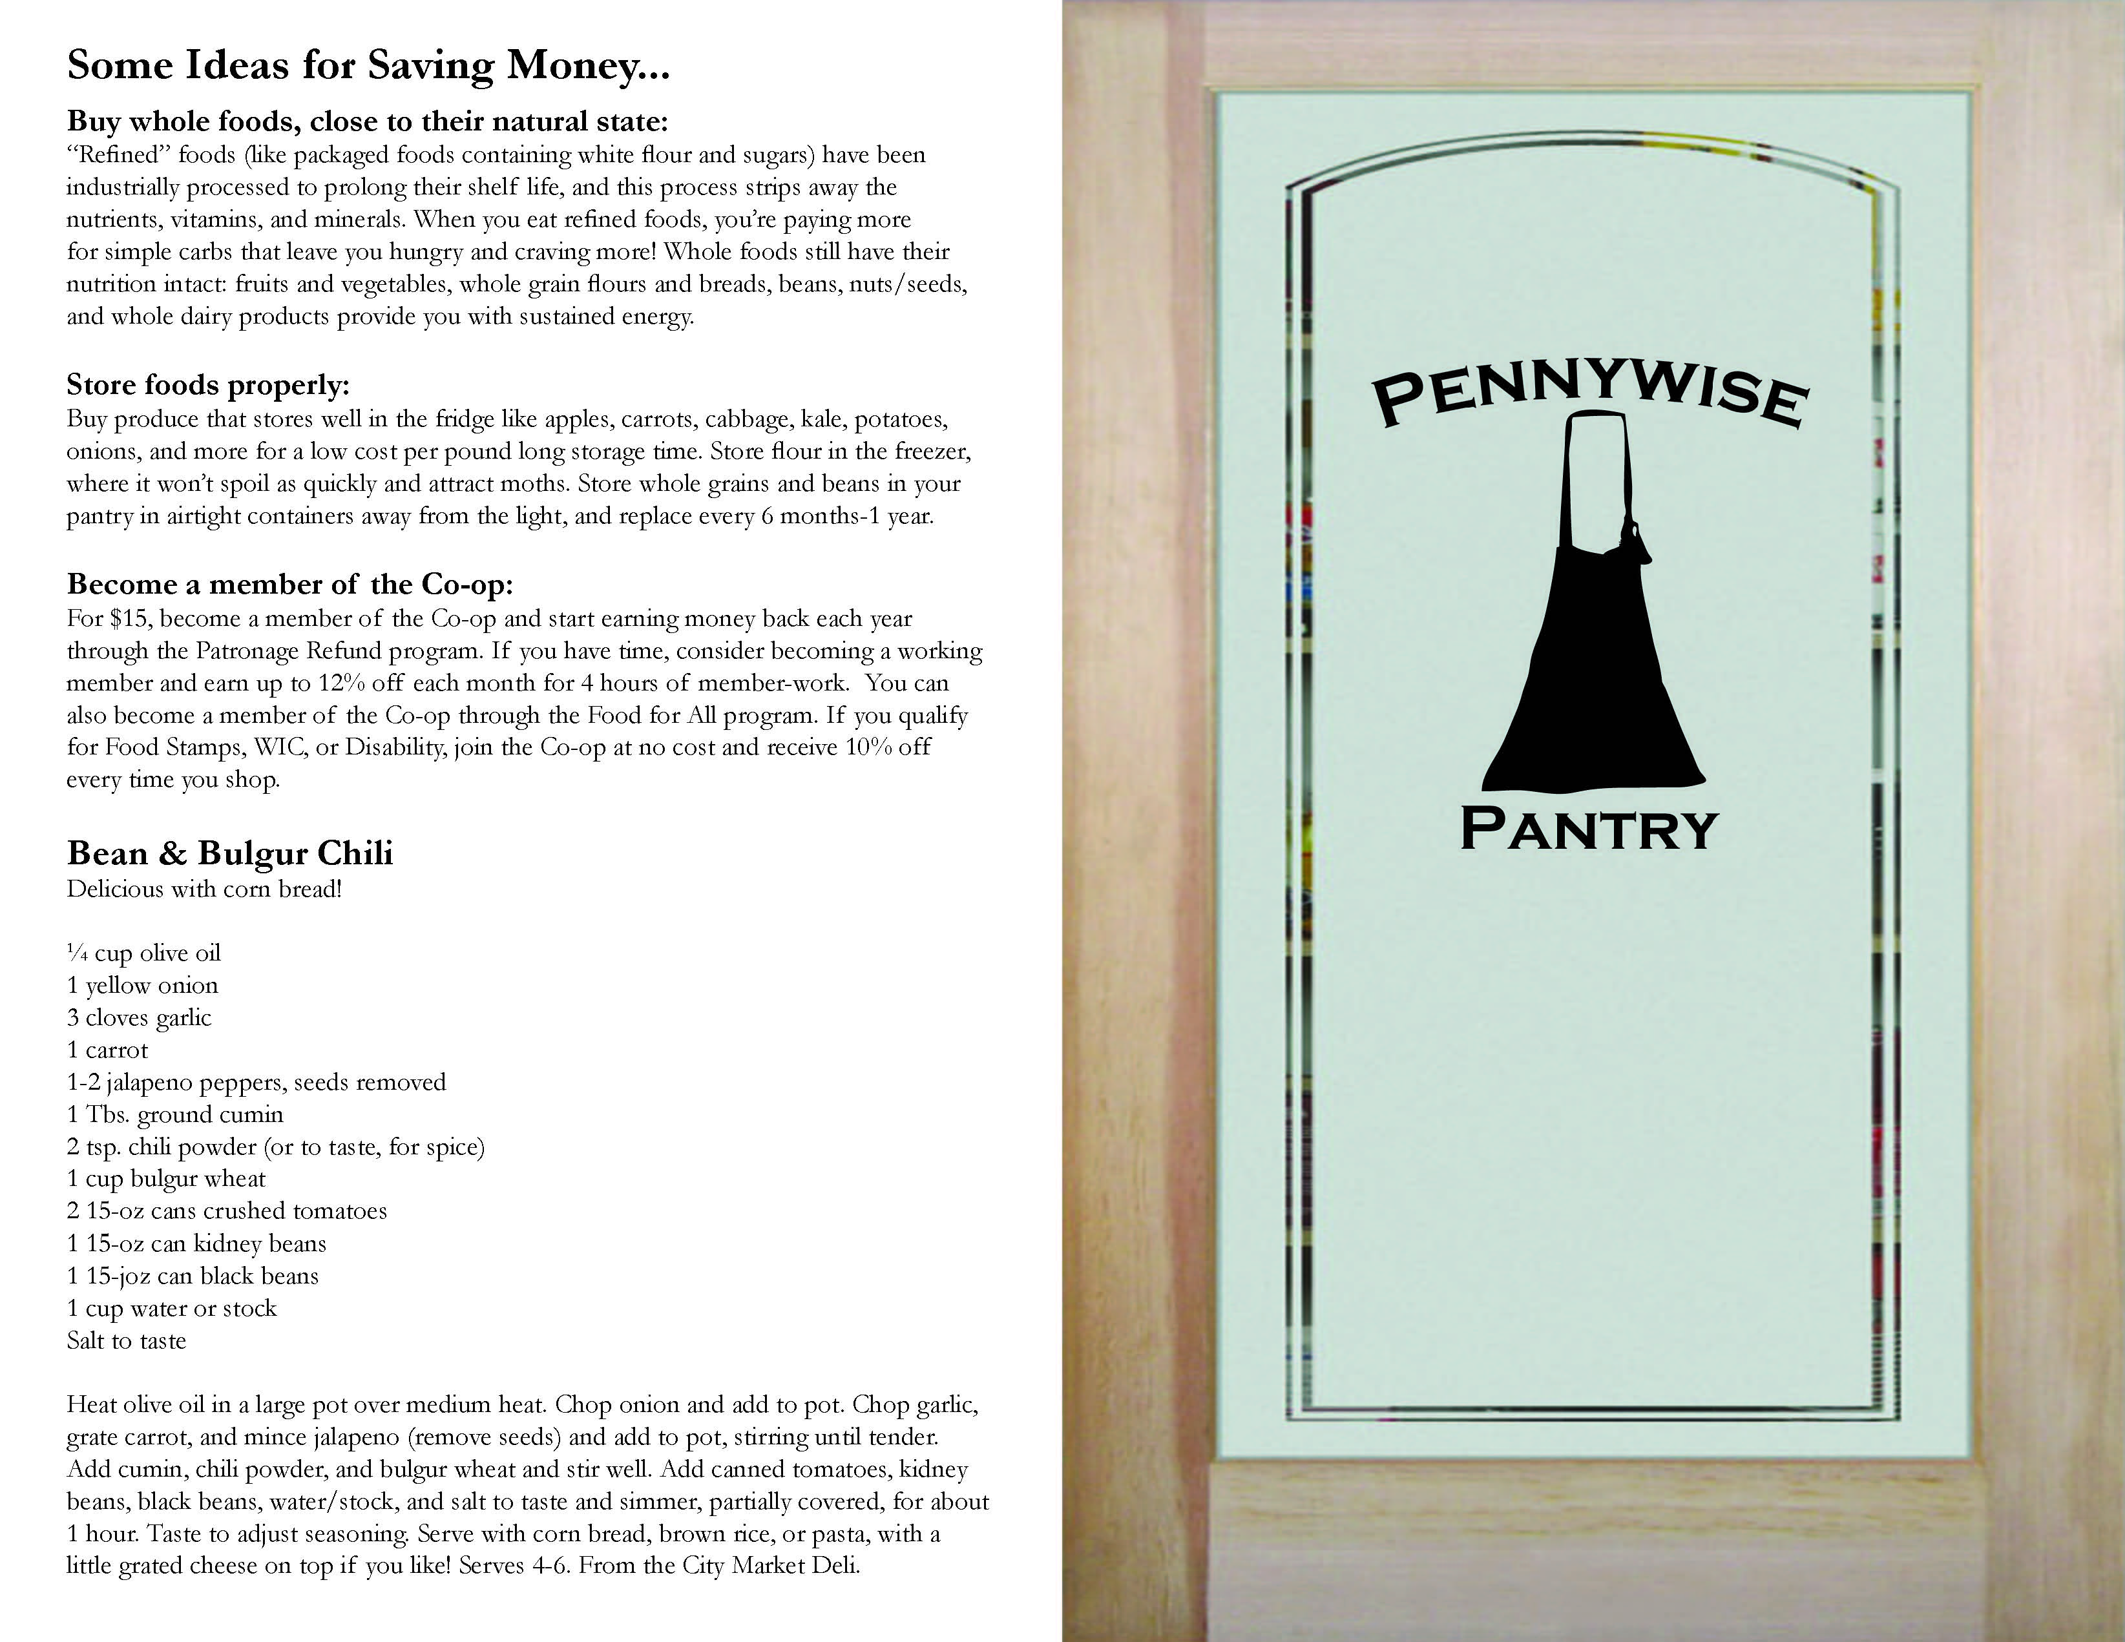

Enrollment Instructions, City Market, Burlington, VT

New & Renewing
Food for All Member Sign Ups
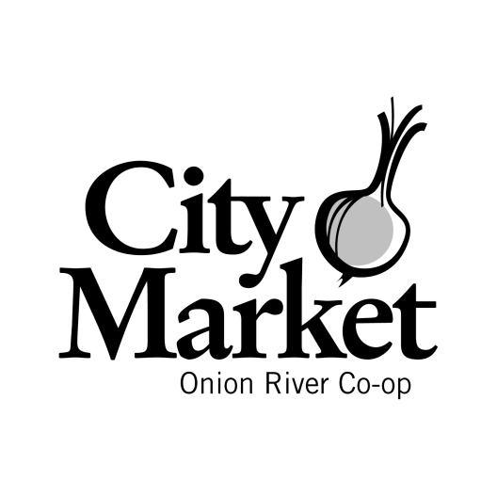

Separate instructions follow for three types of customers:

- Customers who have never been Members.
- Customers who are Members, but have not been FFA Members
- Renewing FFA Members

Questions? Please ask Jarred (x 707), Cristi (x 757), or Allison (x 750)

Customers who have never been Members

Please make sure that there is really not an existing membership so we don’t have duplicates in the system. Explain that the FFA discount is associated with membership. The customer can pay $15 for one year of equity ($200 is considered “paid in full” equity) OR they can claim financial hardship and become a non-shareholding member for a year at a time.
- Make a photocopy of the customers’ proof of eligibility (3Squares card, WIC card or letter, Social Security Disability Income or Supplemental Security Income letter). If you need more information on what we take for appropriate proof of eligibility, please see the Front End FFA Binder. Note: the date on any letters must be within last 1 year.
- If they do not have proof with them, please see the fact sheet for phone numbers they can use to get a copy of their award or reauthorization letter. This eligibility information is required before we can process any FFA paperwork.
- Take an equity form from the FFA Binder. Remove the attached Patronage Card with a temporary 10% discount.
- If the customer would like to pay $15 for equity, scan the Patronage Card and charge them for shares (good for one year of membership). If the customer decides to be a non-shareholding member, let them know that their non-shareholding membership is also good for one year.
- Help the customer fill out the entire equity form, including full names of household members.
- Check the FFA box and circle the appropriate program (WIC, Food Stamps, Disability) based on what they gave you for proof of eligibility paperwork. Be sure to check off the appropriate member types (non-shareholder, new member, etc.).
- Fill out the “For Staff Use Only” section. The member number will already be written on the equity form.
- Give the customer the Patronage Card and a New Member Packet. Let them know: Their discount is active for the term of their membership (one year). Their membership due date is listed on the bottom of their receipts. Their discount will shut off when their membership expires. If they would like to renew their discount, they need to 1) bring updated proof of eligibility to CS and 2) pay $15 or apply for another year of non-shareholding membership. The customer can use their Patronage Card with a temporary discount starting today.
- Attach the photocopy of proof to the equity form and drop it in the Member Services Box behind CS.

Questions? Please ask Jarred (x 707), Cristi (x 757), or Allison (x 750).
Customers who are Members, but have not been FFA Members
- Make a photocopy of the customers’ proof of eligibility (EBT card, WIC card or letter, Social Security Disability Income or Supplemental Security Income letter). If you need more information on what we take for appropriate proof of eligibility, please see the Front End FFA Binder. Note: the date on any letters must be within last 1 year.
- If they do not have proof with them, please see the fact sheet for phone numbers they can use to get a copy of their award or reauthorization letter. This eligibility information is required before we can process any FFA paperwork.
- Look their name up in our system and get their member number, even if their account is inactive. Current members have three options:
- If the customer would like to pay $15 for equity, scan their Patronage Card and charge them for shares (good for one year of membership).
- If the customer has current equity, they do not need to pay. However, their discount will shut off when their membership expires (they will need to reapply with their proof of eligibility to continue the discount).
- If the customer has an account with lapsed equity, they can choose to become a non-shareholding member. Important: Let them know that their non-shareholding membership is also good for one year. They can pay $15 at any time or at the end of the year.
- Help the customer fill out a blank equity form, including full names of household members.
- Check the FFA box and circle the appropriate program (WIC, Food Stamps, Disability) based on what they gave you for proof of eligibility paperwork. Be sure to check off the appropriate member types (non-shareholder, new member, etc.).
- Fill out the “For Staff Use Only” section, including their current member number.
- If the customer needs more member cards, request more in the M2.
- Let them know: Their discount is active for the term of their membership (up to one year). Their membership due date is listed on their store receipts next to their name. Their discount will shut off when their membership expires. If they would like to renew their discount, they need to bring updated proof of eligibility to CS and pay $15 OR apply for a year of non-shareholding membership. The FFA discount will be activated in 3-5 business days.
- Attach the photocopy of proof to the equity form and drop it in the Member Services Box behind CS.

Questions? Please ask Jarred (x 707), Cristi (x 757), or Allison (x 750).
Renewing FFA Members

- Make a photocopy of the customers’ proof of eligibility (EBT card, WIC card or letter, Social Security Disability Income or Supplemental Security Income letter). If you need more information on what we take for appropriate proof of eligibility, please see the Front End FFA Binder. Note: the date on any letters must be within last 1 year.
- If they do not have proof with them, please see the fact sheet for phone numbers they can use to get a copy of their award letter. This eligibility information is required before we can process any FFA paperwork.
- Charge the customer $15 for equity OR let them apply to be a non-shareholding member.
- Ask if their contact information (address, phone and email) is the same. If so, use the FFA Renewal stamp on the copy of the documentation and fill in all fields. If any information has changed, fill out an equity form including their household members, member number, etc.
- Request new cards if they need them through the M2.
- Let the customer know that it takes 3-5 business days to reactivate a discount and that the next due date is listed next to their name on their store receipts.
- Attach the photocopy of proof to the equity form and drop it in the Member Services Box behind CS.

Questions? Please ask Jarred (x 707), Cristi (x 757), or Allison (x 750).

FLOWER Application, GreenStar Co-op, Ithaca, NY
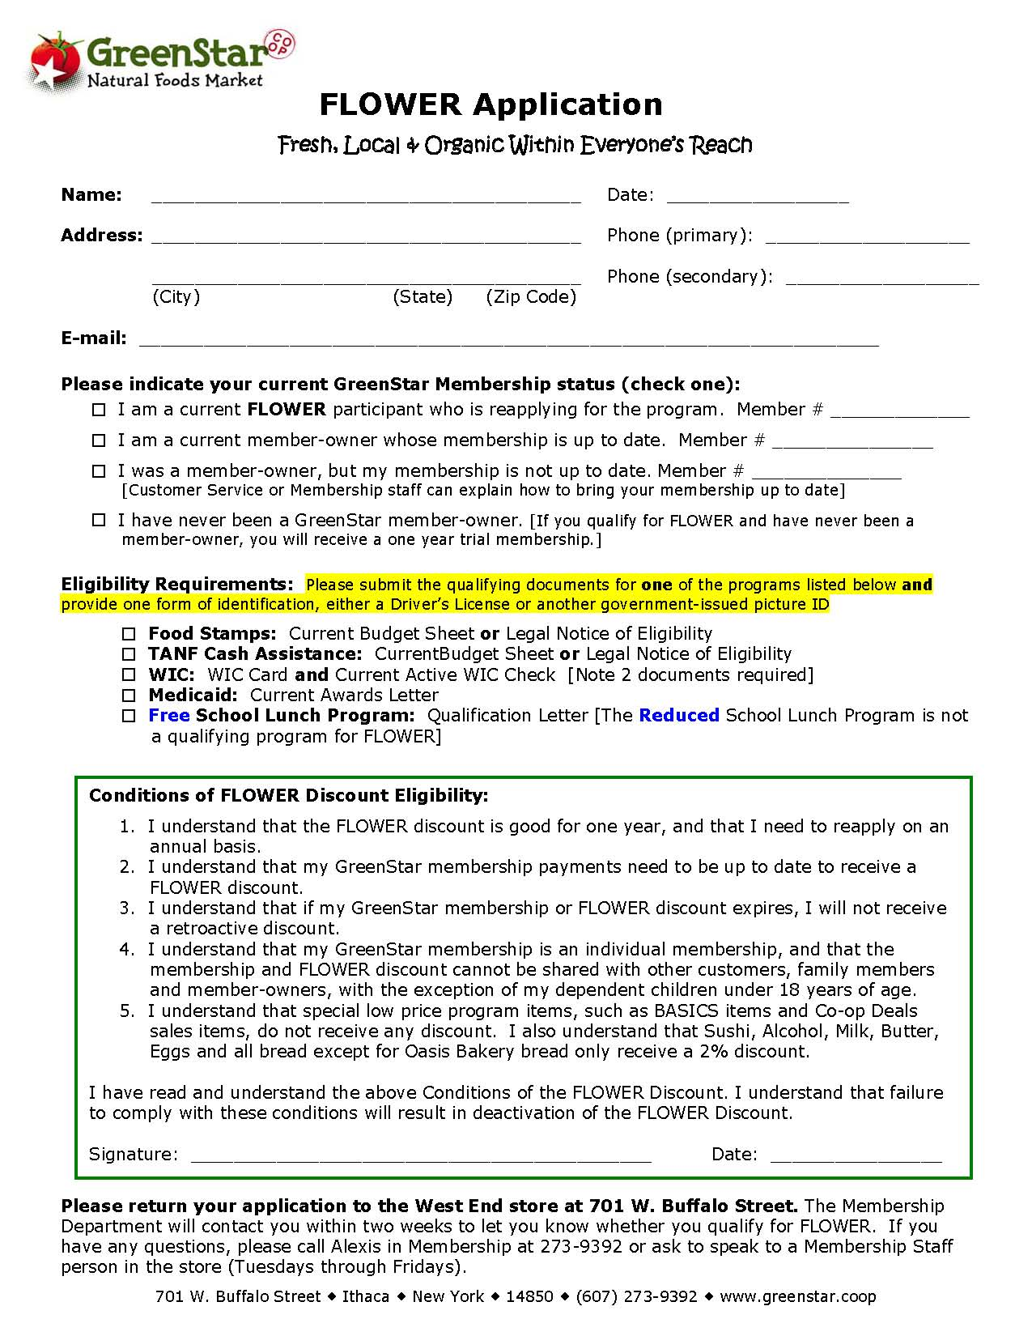
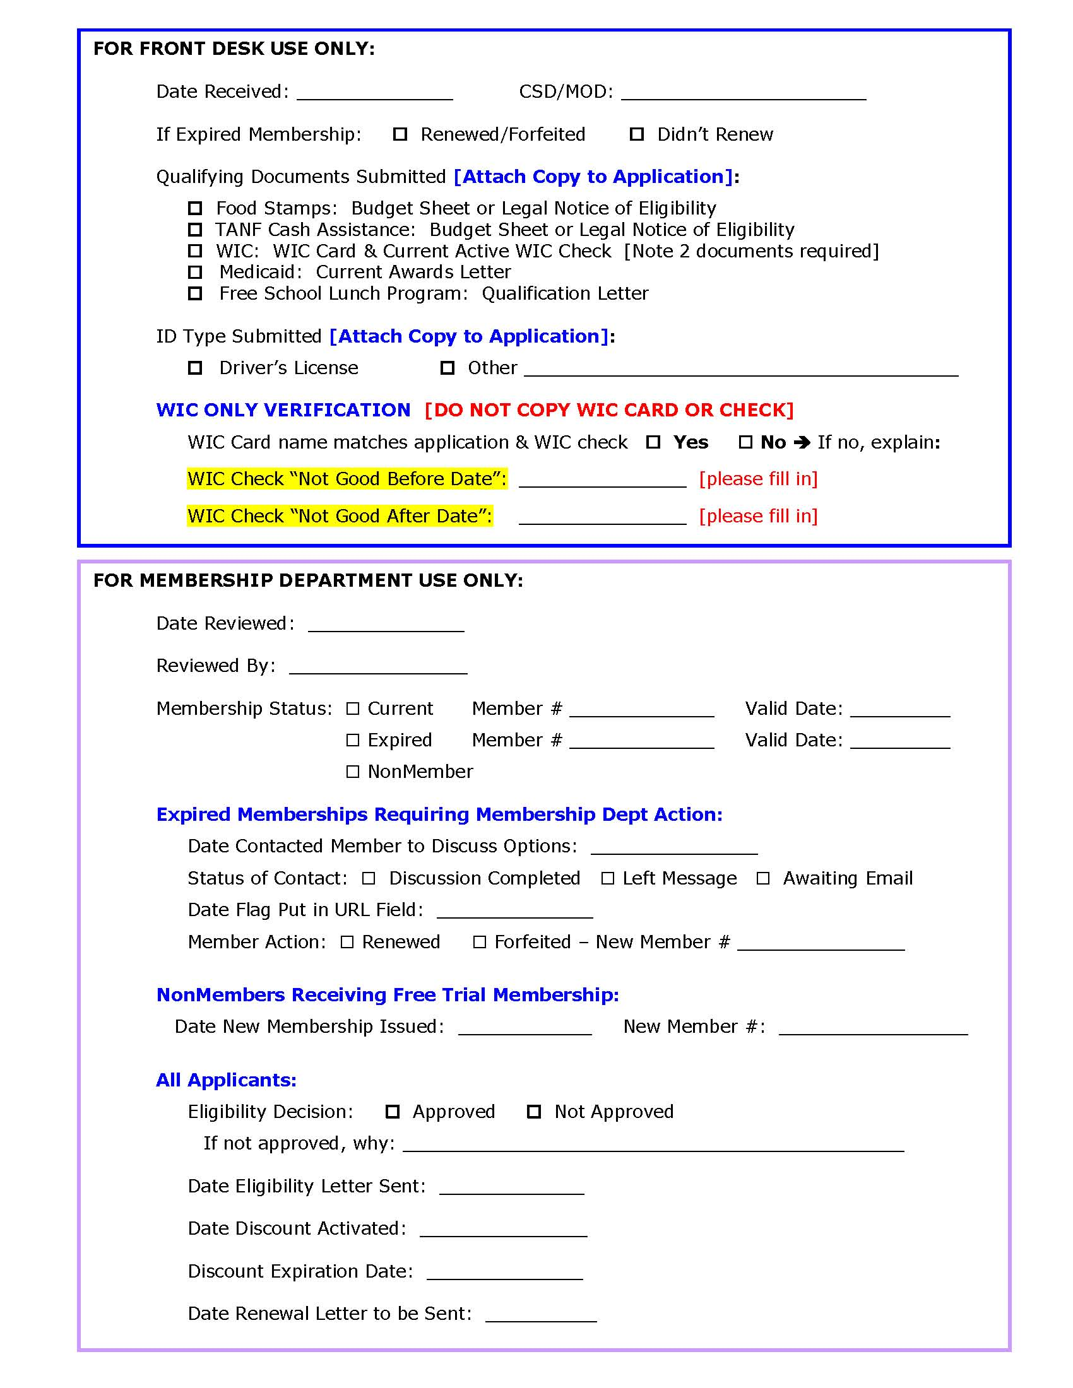

FLOWER Flier, GreenStar Co-op, Ithaca, NY

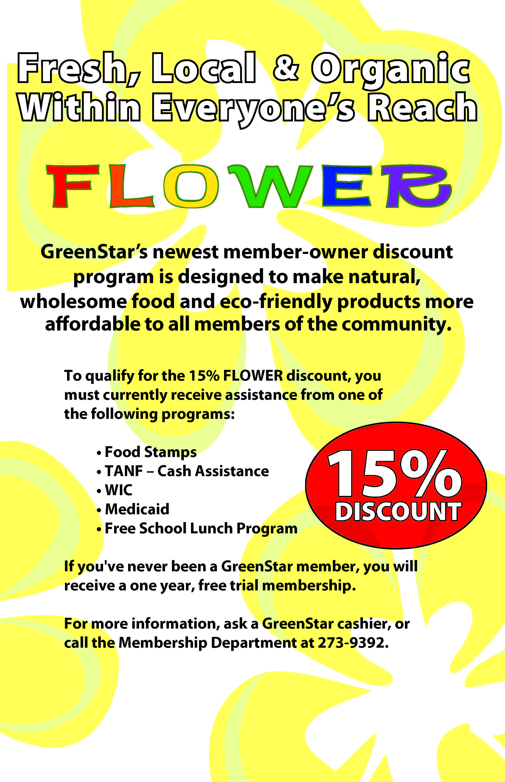

FLOWER Brochure, GreenStar Co-op, Ithaca, NY
