Real Pickles is Going Co-op!
By Dan Rosenberg and Addie Rose Holland, Real Pickles
(633 words)
You know the difference that co-ops make in your community. As part of our contribution to the vision of a Co-operative Decade, the Neighboring Food Co-op Association is working to demonstrate the relevance of co-operative enterprise in our communities, and to connect co-ops and their members to create a more vibrant, sustainable and democratic economy in our region. One example is Real Pickles, a regional producer of naturally fermented organic vegetables, which recently announced its conversion to a co-operative enterprise:
We have big news to share: Real Pickles is becoming a co-op!
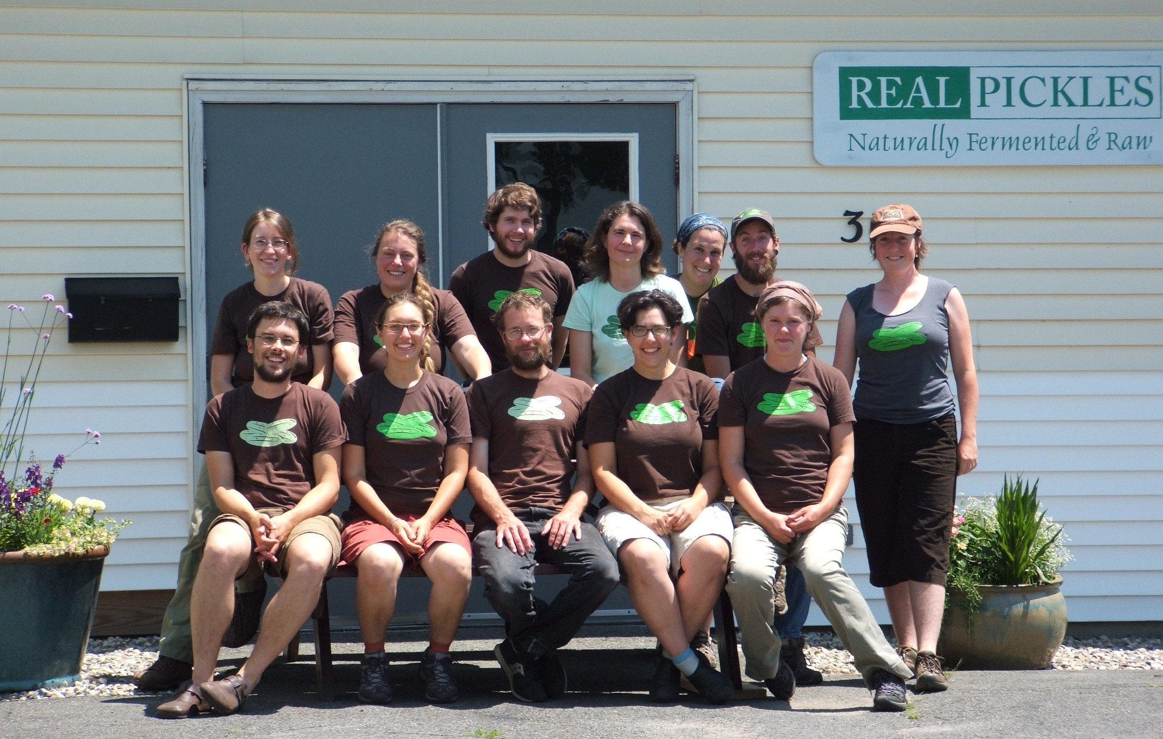
We have been laying the groundwork for a transition for a number of months now, and this past summer – during the United Nations International Year of Co-operatives – we officially decided to make the switch to a worker-owned co-operative. As part of our transition, we are offering an opportunity for the community to invest in the local food system by purchasing non-voting stock (available to residents of Massachusetts and Vermont) in our new co-op.
As the founding owners, we have worked hard over the last decade to build up our business: creating our recipes, developing markets, and learning to manage the challenges posed by our commitment to sourcing locally within the short span of the New England growing season. Now in our 12th year, we have a fantastic staff of 12 and our business is financially solid. We operate out of a 100% solar-powered, energy-efficient facility. We are supplying over 300 food co-ops, natural food stores and farmstands across the Northeast with delicious, nourishing food. This year, we are purchasing nearly 200,000 pounds of certified organic vegetables from local farms.
Where do we go from here? The typical path for a business like ours would be continued growth followed by selling out to a large, industrial food corporation. Real Pickles has a mission of promoting regional agriculture, and a strong vision for change in the food system. We want to be following a model that will support these goals, and so we have decided to help re-write the standard storyline for a successful organic food business
As a co-operative, Real Pickles' social mission and guiding principles will be inscribed into our articles of organization and bylaws, making them difficult to change. The business will remain rooted in the community. Our staff will have access to true ownership and the opportunity to share in the decision-making and profits. And, we will be joining a community of cooperative business in our region that is committed to a healthy, just and sustainable food system and economy.
In exploring options for financing our transition, we found that other mission-based co-ops (notably Equal Exchange and Organic Valley) have used non-voting stock as a way to raise funds. We have chosen to follow a similar path and have set up a stock offering, with shares available to residents of Massachusetts and Vermont. We set the minimum investment as low as $2,500, with the goal of encouraging broad community participation in our endeavor.
Everyone at Real Pickles is excited about becoming a co-op, and we are encouraged by the support we have received from the wider community in this transition. We believe that this direction will help ensure our success far into the future – producing delicious and healthy food, making a lasting contribution to building a new and better food system, and creating an alternative path for sustaining local businesses and economies!
Real Pickles’ vision has much in common with that of the Neighboring Food Co-op Association’s (NFCA), and we are excited about the opportunity to work together as we build a more healthy, just and sustainable food system.

[If your food co-op offers Real Pickles products, mention that here. If not, leave blank.]

Find more information about Real Pickles, their co-op transition, and their stock offerings at www.realpickles.com.

