CELEBRATE INTERNATIONAL CO-OPS DAY!
JULY 4th 2020

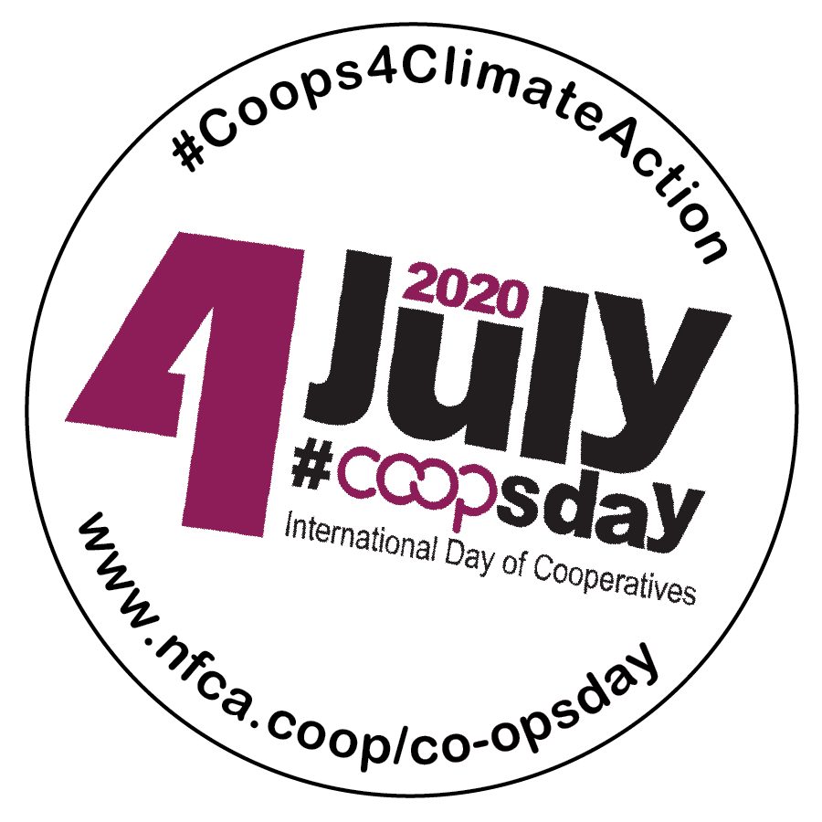

Co-ops 4 Climate Action!
International Co-ops Day is a great opportunity for your food co-op to join with other co-operatives and credit unions in spreading the word about the Co-operative Difference. This year’s theme, “Co-ops 4 Climate Action,” highlights the role of co-operatives as a more sustainable way of doing business as we work collectively to address the challenges of climate change and build a green and just future for everyone.
Here in our region, our food co-ops are important employers and providers of good, local jobs, and access to employee ownership. In this packet you will find a few resources to help you communicate our shared impact:
- Use our template press release (see next page) to share what you're doing with local media outlets and in your own newsletter, website or blog.
- Promote your co-op's sustainability efforts using social media (see page 3) and the hashtags #CoopsDay and #Coops4ClimateAction.
- Include your food co-op in the International Co-operative Alliance's (ICA) interactive map of co-ops taking action on the climate.
- Participate in the ICA's photo competition with an image that tells the story of what your co-op is doing to address climate change (deadline June 25).
- Submit a video! What kind of world do you want to see in 10 years? Share it in a 30 second (or less) video and submit it to the ICA (deadline June 22).
For more background on International Co-ops Day, visit www.nfca.coop/co-opsday.
Please send a copy of anything you print or a link to online publications to erbin@nfca.coop. Thanks!

In Co-operation,
Erbin, Bonnie & Suzette
Sample Press Release / Newsletter Story for NFCA Member Food Co-ops
International Co-ops Day is a great opportunity for your food co-op to join with other co-operatives and credit unions in spreading the word about the Co-operative Difference! We’ve drafted this story for you to adapt for use in your food co-op’s newsletter or e-news, blog, website, and as a press release to send to local media. You can also use excerpts for social media posts, using #CoopsDay. Please send a copy of anything you print or a link to online publication: erbin@nfca.coop. Thanks!

Contacts:
Your Press Contact Name  Your Co-op  Your Phone Number  Your E-mail | Erbin Crowell, Executive Director  Neighboring Food Co-op Association  Tel: 401-419-0381  E-mail: erbin@nfca.coop
FOR IMMEDIATE RELEASE – [DATE]:
[Your Co-op] Joins Celebration of International Co-ops Day

[Your City or Town] – On Saturday, July 4th, [Your Co-op] is joining co-operatives and credit unions around the world in celebrating International Co-ops Day. This year’s theme, Co-ops for Climate Action, highlights the role of co-operatives in building a more just and green future for everyone.
[Use this space to give specifics about some of the ways that your Food Co-op contributes to sustainability and climate action. You could also include a quote on these efforts by a General Manager, Staff or Board Member, or a representative of a community organization that your co-op works with on these issues.]
“Our common home is in danger,” said Ariel Guarco, President of the International Cooperative Alliance (ICA). “We must act now, with our values and principles, to demonstrate on a global scale that it is possible to develop an economy with social inclusion and protection of natural resources.”
International Co-ops Day has been celebrated annually since 1923, and the theme this year was chosen to support the United Nations Sustainable Development Goal on Climate Action. The event will focus on the contribution of co-operatives to combating climate change, one of the most severe challenges facing our planet during the 21st century, as we build a more inclusive economy and society.
“Across our region, food co-ops have been leaders in building a more sustainable food system,” said Erbin Crowell, Executive Director of the Neighboring Food Co-op Association (NFCA). “And with climate change and economic inequality as urgent challenges, food co-ops are taking the lead in working for climate justice, working together to ensure a more healthy, just, and sustainable future for everyone.”
For example, the UN Food & Agriculture Organization has pointed to organic agriculture as a tool for reducing energy consumption and the negative effects of energy emissions, sequestering carbon in the soil, and increasing the resilience of family farms. Food co-ops were pioneers in helping to build the market for organic foods, and continue to demonstrate this commitment. Last year, member co-ops of the NFCA sold an estimated $97 million in organic products, supporting human health, sustainable agriculture, and a more resilient food system.
As our communities around the world work to rebuild in the wake of the COVID19 pandemic, co-ops offer an opportunity to envision a more inclusive economy. As part of Co-ops Day celebrations, food co-ops across the Northeast are using this important opportunity to demonstrate their commitment to sustainability and to working together to address climate change and achieve a fair, green and just future for all.
Celebrated internationally on the first Saturday in July, Co-ops Day in the United States coincides with Independence Day, offering a unique opportunity to focus on the democratic values of the co-operative business model. Based on the principle of one member one vote, co-ops reflect American ideals of democracy, self-help, self-responsibility, and social responsibility. And because co-operatives are focused on meeting member needs rather than maximizing profit, they are focused on goals identified by their members, including social, economic and environmental sustainability.
[Depending on the timing of your release, you may also want to mention any special events or offers you have planned for July 4th weekend.]
For more information, please visit https://nfca.coop/co-opsday/.
## END ##
[±530 words with added content.]
For additional Co-ops Day social media ideas and graphics, see next page.
Sample #CoopsDay Social Media Posts
Copy and edit these template posts for your co-op’s use. See next page for Co-ops Day logos and images.
FACEBOOK
Posts for the two weeks leading up to July 4:
#CoopsDay is coming up on July 4, 2020! The @UN International Day of Cooperatives celebrates #Coops4ClimateAction and how co-ops are supporting environmental justice! https://nfca.coop/co-opsday/
On July 4, celebrate #CoopsDay with your local food #coop! Your @Neighboring Food Co-op Association member co-ops sell more than $97 million in organic products annually, supporting a more sustainable food system! https://nfca.coop/co-opsday/
#CoopsDay is coming up on July 4, celebrating the #coop contribution to Healthy Food, Healthy People, and a Healthy Planet! www.nfca.coop/co-opsday/
@UN #CoopsDay is coming up on July 4. Did you know that together our Vermont Neighboring Food #Coops are among the top 25 employers in the state? https://nfca.coop/about
July 4 is International #CoopsDay, celebrating the contribution of #coop businesses to #ClimateAction & #ClimateJustice. https://nfca.coop/co-opsday/
Co-ops are celebrating #CoopsDay and #ClimateAction on July 4! Food co-ops in the Northeast have lower staff turnover and more staff employed fulltime than supermarkets in our region. For more info, check out: https://nfca.coop/co-opsday/
We’re celebrating #CoopsDay on July 4 with #coop members around the world! Take a look at this interactive map of events developed with @DotCoop: https://maphub.net/DotCoop/CD2020
Take this opportunity to also post photos of staff, produce departments, and environmental initiatives, using #CoopsDay.
Post for July 4:
Happy International #CoopsDay! Come down to your food #coop and celebrate sustainability with the best staff on the planet. [Post with a photo of staff.]
Happy International #CoopsDay! Together, we’re taking #ClimateAction and building a more just and sustainable future for everyone! [Post with a photo of staff, a co-op event, or an environmental initiative.]
TWITTER
Posts for the two weeks leading up to July 4:
On July 4, celebrate #CoopsDay with your local food #coop! Here in the Northeast, our @Neighboring Food Co-op Association member co-ops sell more than $97 million in organic products, supporting a more sustainable food system! https://nfca.coop/co-opsday/
#CoopsDay is coming up on July 4, celebrating the #coop contribution to #ClimateAction & #ClimateJustice! https://nfca.coop/co-opsday/
The 25th Annual @UN #CoopsDay is coming up on July 4. Did you know that together our Vermont Neighboring Food #Coops are one among the top 25 employers in the state? www.nfca.coop/about
July 4 is International #CoopsDay, celebrating the contribution of #coop businesses to sustainability. https://nfca.coop/co-opsday/
Co-ops are celebrating #CoopsDay and good #ClimateAction on July 4! Food co-ops in the Northeast are committed to sustainable sourcing practices. For more info, check out https://nfca.coop/co-opsday/
We’re celebrating #CoopsDay on July 4 with #coop members around the world! Take a look at this interactive map of events developed with @DotCoop: https://maphub.net/DotCoop/CD2020
Take this opportunity to also post photos of staff, produce departments, and environmental initiatives, using #CoopsDay.
Posts for July 4th:
Happy International #CoopsDay! Come down to your food #coop and celebrate sustainability with the best staff on the planet. [Post with a photo of staff.]
Happy International #CoopsDay! Together, we’re taking #ClimateAction and building a more just and sustainable future for everyone! [Post with a photo of staff, a co-op event, or an environmental initiative.]
#CoopsDay Images

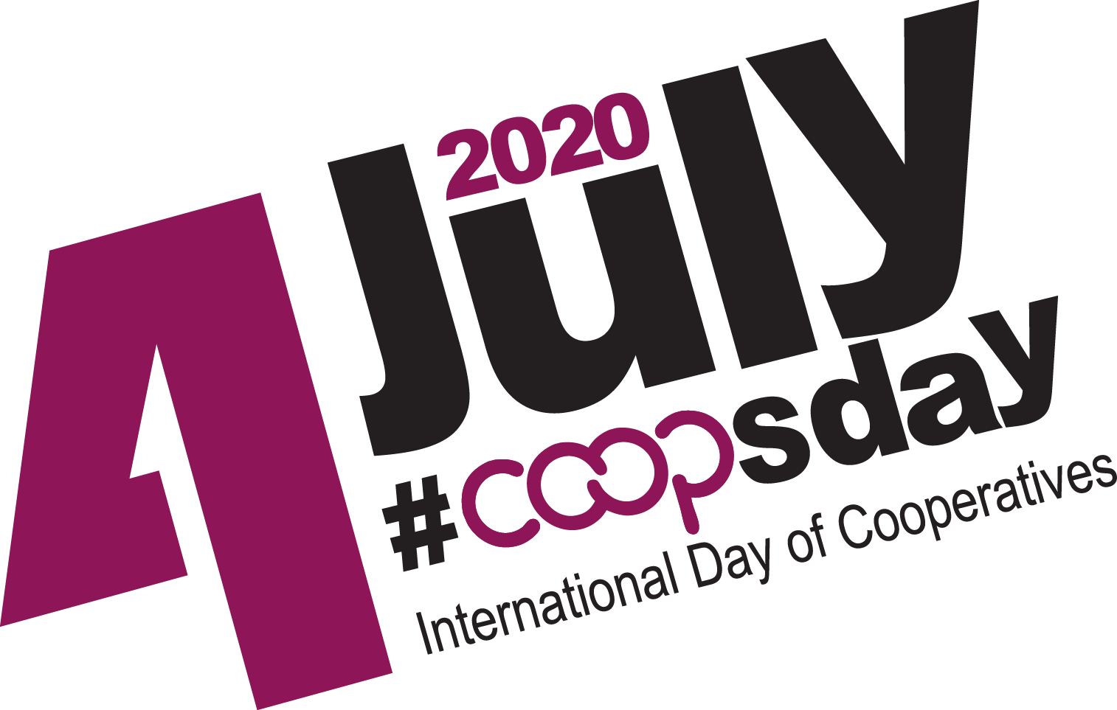

For additional images, visit https://www.ica.coop/en/2020-international-day-cooperatives.

